Insect modeling with individual observations: development time

BioSIM is able to calibrate parameters of 48 development rate equations (see DevRateEquations.pdf for definition) based on individual development time at fixed or random variable temperature regime as long as the temperature was recorded, for example with a HOBO logger.

Using HOBO recorded temperature let the possibility to:
- Use data even if the growing chamber did not work correctly
- accelerate when the experimentation is to long or mortality is too high
- slow down experimentation when mortality to too high

The calibration is based on the Régnière 2012 article and used a Simulated Annealing algorithm to optimization parameters.

In this tutorial, you will learn how to format your data, define BioSIM component to calibrate development time/rate and plot your result with R.

When curve is fitted, user can use the BioSIM model base template to implement a new model in C++ and add it to BioSIM model library. Help to do this task can be provide by BioSIM team. Here we will see how to use the class CDevRateEquation to compute mean rate in function of temperature and an individual stochastic relative development rate.

Preparing the data

Input files to prepare
- Development time input file
- Temperature input file (in case of random temperature regime)

all input files must have a CSV (comma separate value) text format. All mandatory columns must be present (in any order). BioSIM will ignored all others columns.
All files must be in the “Input\” sub directory of the BioSIM project.

Development time data file

The development time input file is compose of 4 mandatory columns:

1 | Variable | The variable (stage) name (ex “Egg”, “Larva”, “Pupa””Adult”)
2 | T | The treatment temperature in case of fixed temperature or a temperature ID, for example “Room01”, referenced to a temperature ID in the input temperature file. Temperature ID must imperatively have at least one letter to be able to distinguish with fixed temperature.
3 | Time | Number of days to complete the stage
4 | N | Number of individual that take “Time” days to complete the stage

The temperature input file have 2 mandatory columns

1 | ID | ID of the treatment. For example “Room01”
2 | T | All hourly temperature [°C] since the beginning of the experimentation.

First Guess Calibration of development time

To calibrate development time, we fit parameters of development rate equation to maximize the log likelihood based on the probability of individual to change stage using observation of development time.

The first step will be to test all models to evaluate the most appropriate model for the data.

We assume here, you already have created a BioSIM project and the input data need are copied into the input sub directory of the project
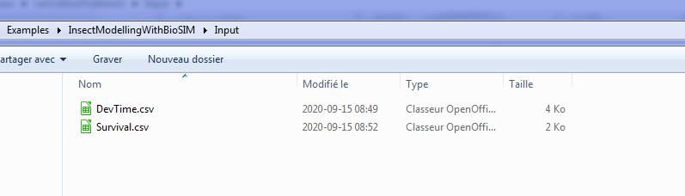
In BioSIM, add a new group() name “Development Time” and add a new “Calibration Curve” component().

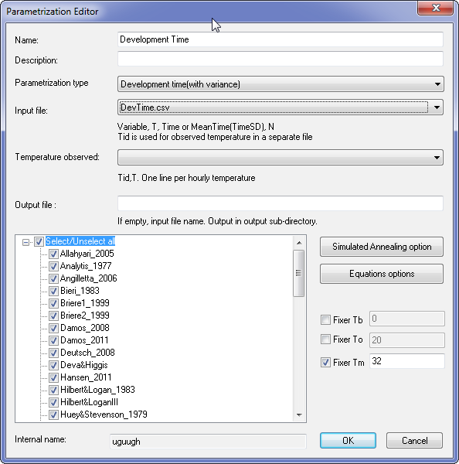

In the Parametrization Editor, select “Development Time (with variance)” that let BioSIM to calibrate the development time and the relative development time (variance between individual) at the same time.

Select your input file, in this case DevTime.csv.
Because this file only have fixed temperature, there is no temperature input file. Let this field empty.

You can let the output file name empty. By default BioSIM will save result in the “Output/” sub directory of the project with the same name as the input file.

Select all development rate equation for exploration.

When data do not clearly show an increase of developmental time at high temperature, user can limit the upper threshold in a valid biological range. In this case, BioSIM will fix the upper limit for all model that have an upper temperature threshold (“Tm” parameter). This do not affect model that do not have upper limit, for example linear model. For L osakensis, a reasonable value can be estimated at 32°C.

The Simulated Annealing options let the possibility to change the internal way BioSIM try to find a best parameters. You can use the default values.
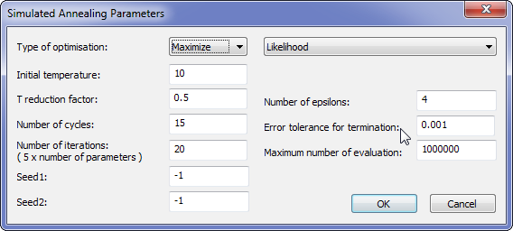

The Equations options let the possibility to define the parameters initial values and its range separately for each model. You can use the default values. Fixed Tb, To, Tm have priority over these options.
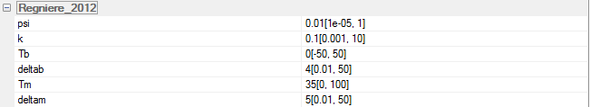

Click on OK


To generate the images of the graphics, select the development time component() add an R script component ().
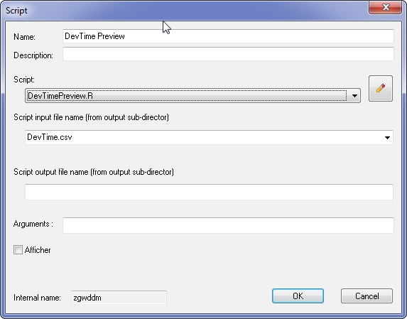

In the script dialog, select the script DevTimePreview.R

Enter DevTime.csv as input for the script. This file will be generated by the Calibration Curve component.

Click on OK

To execute these tasks, click on Execute Checked ()

It is a very long process. To give an idea, on a Pentium I-7 with 8 CPU, BioSIM took ~4 hours to calibrate 48 equations for the 8 variables (384 equations)

Analyzing the result

When finished, you will find the result file into the “/output” sub-directory of the project.
The output file contain the following columns:
Variable | Name of the variable, same as input, for example “Egg”
EqName | Name of equation, for example “Briere2_1999”
P | Parameters name and estimated value, for example To=2.545675e+01...
Eq | The R expression equation used by R parse function
Math | The mathematical representation used by R expression function
AICc | The Akaike information criterion
maxLL | The maximum log-likelihood

If the script file was correctly executed, the images of all fitted curve with observation will be created into the “images/” sub directory of the project.

For each variable, the R script will create a condensed images with the 48 models. Optionally, there is a ls a flag (PRINT_DETAILED) into the script file that can be turn to TRUE to split the image into 2 images of 24 models.

Example of “Preview” of all development rate model. You will get “preview” for each stage:
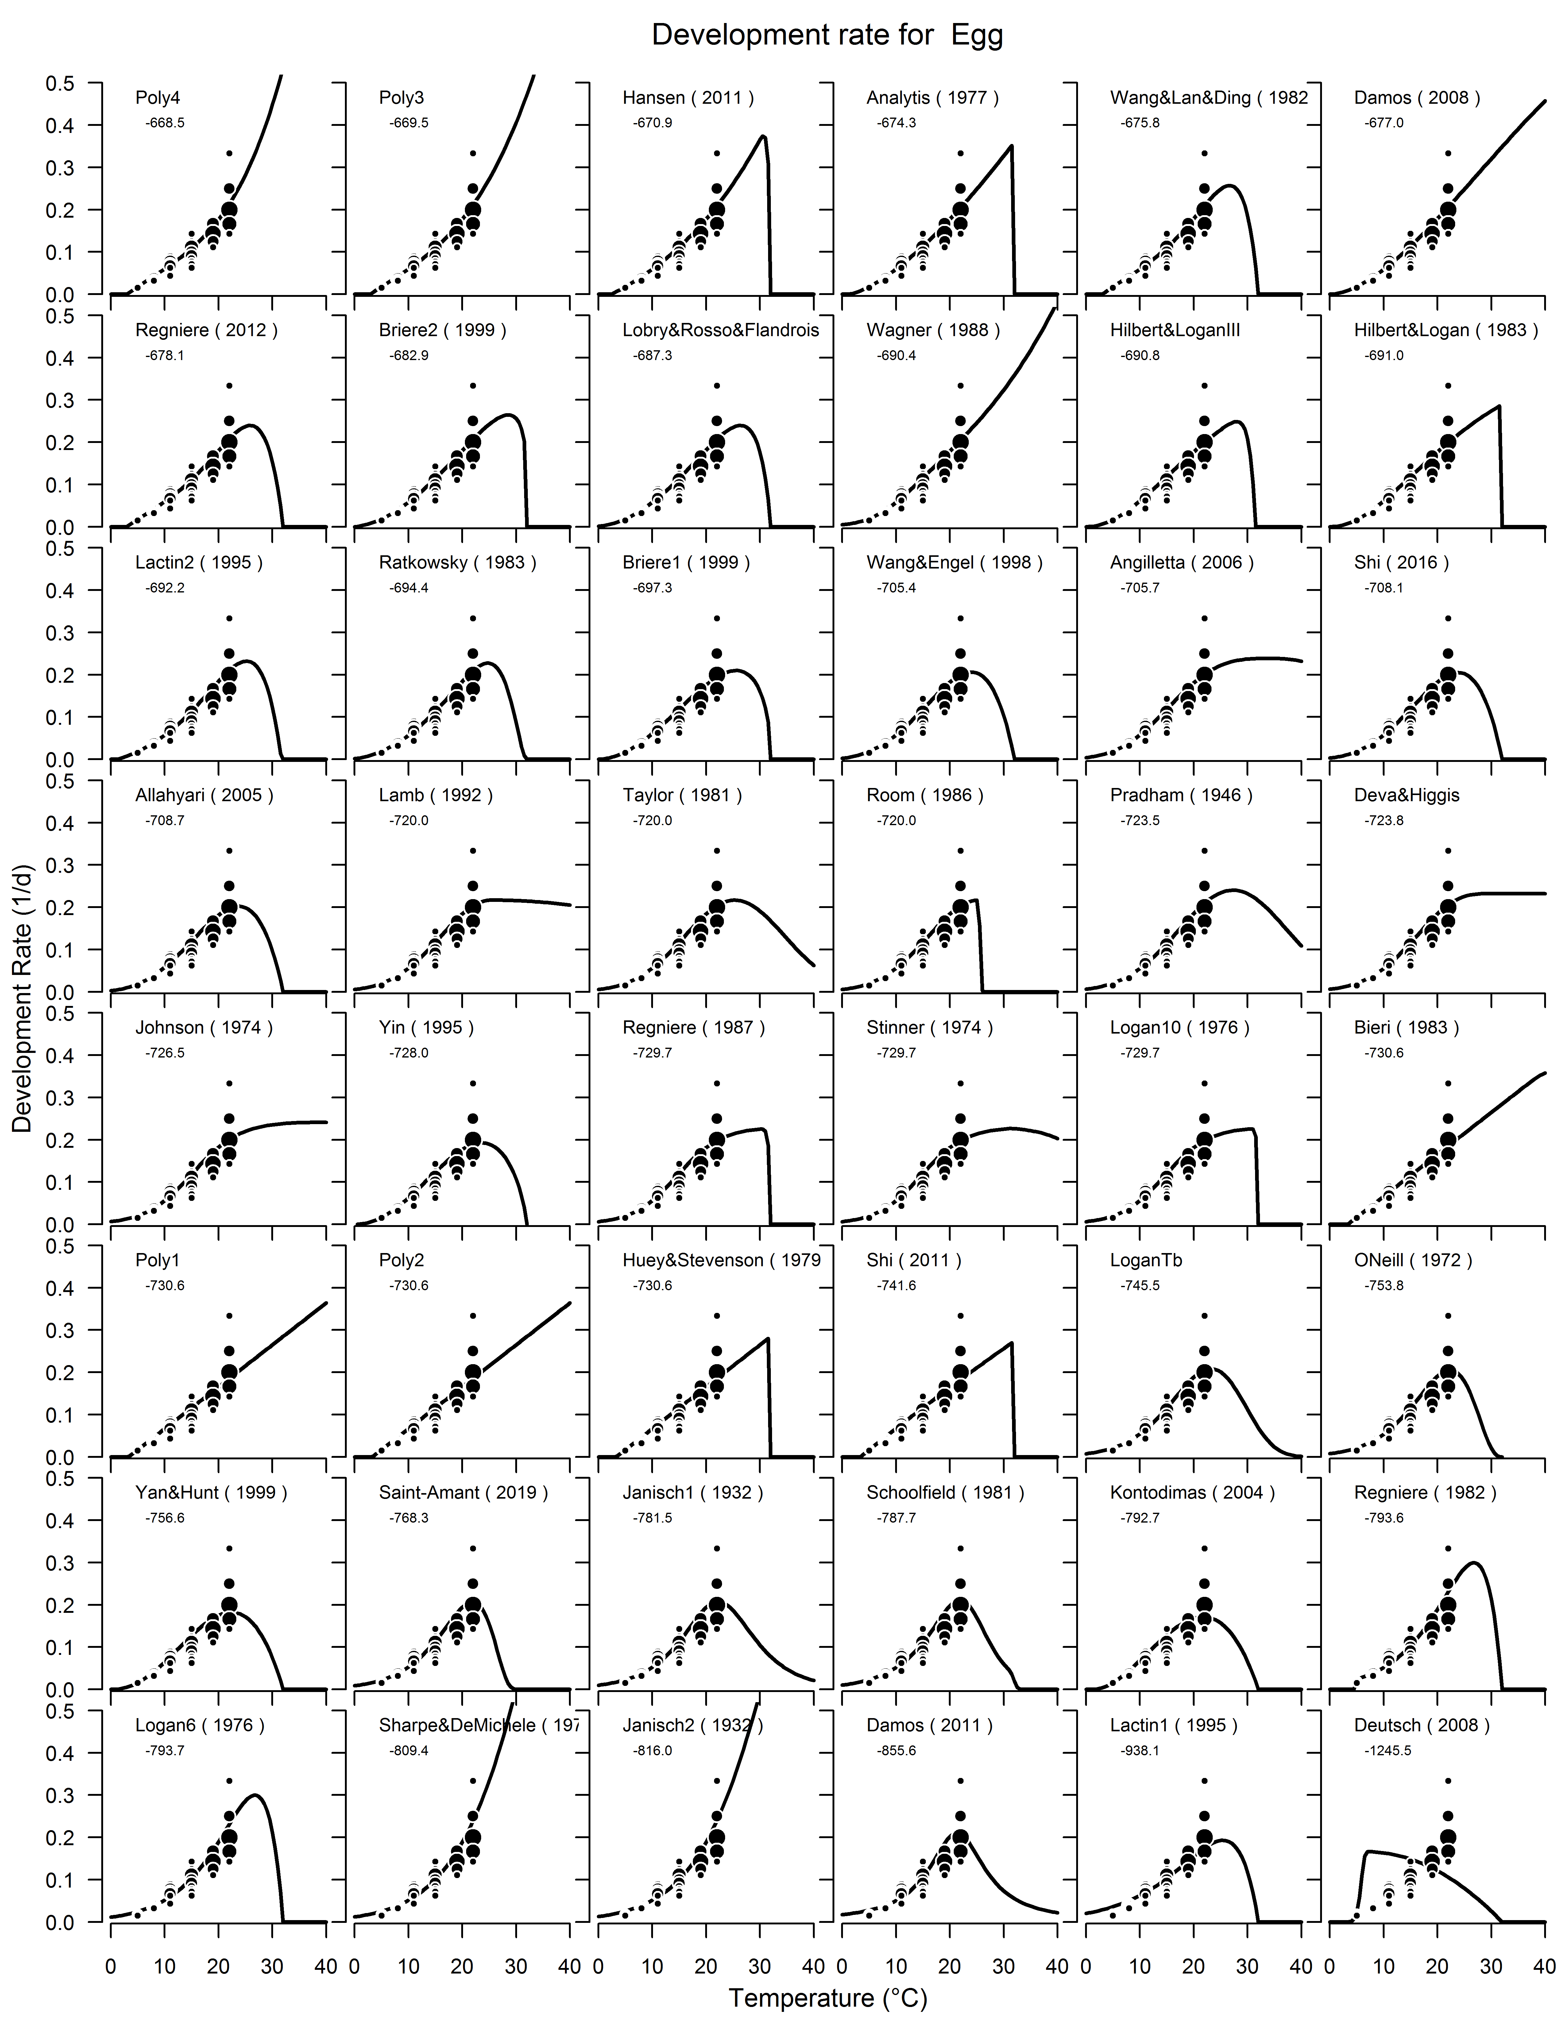
Selecting the 3 best models

The second step is to select the best model base on some criteria. The ideal case is when the maxLL give the best model, but it’s not always the case. For example, when a biological upper threshold (Tm) is define, the best maxLL will usually be model without Tm parameters. So you have to discard these models. Also, the evaluation of the model before lower observation but moreover after upper observation must be done. Some models have explosive curve and some models have more conservative one. Base on the assumption that fast individual have more probability to survive, it can be assume that at high temperature, when survival is low, the observation can be overestimate by low survival. In this case, it can be appropriate to select a conservative model.

A different model can be selected for each stages or an effort can be done to try to limit the number of models. We can evaluate the global score for all stages.

To see the score of the entire stages, we do the mean of maxLL over all stages. In the case of L. osakensis, we got:

EqName | maxLL
Poly4 | -350.4
Poly3 | -353.9
Regniere_2012 | -355.5
Wang&Lan&Ding_1982 | -355.9
Hansen_2011 | -358.8

If we eliminate the poly4 and poly3, the 3 best models are the Regniere 2012, Wang&Lan&Ding 1983 and Hansen 2011.

After that, we have to evaluate the best model for each stage to see if these 3 best models are realistic for all stages.

After determining the 3 best models, add a new “Curve Calibration”(), select the 3 best models and enter a new output name like DevTime3BestModel.
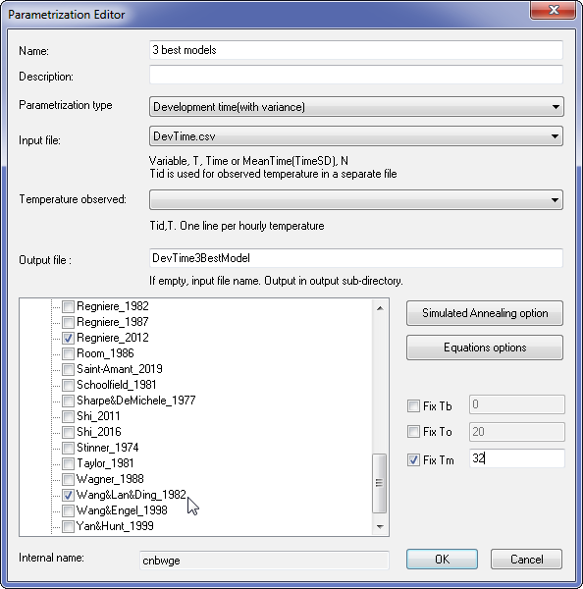
In the Simulated Annealing option, we can enter a more accurate search criteria.
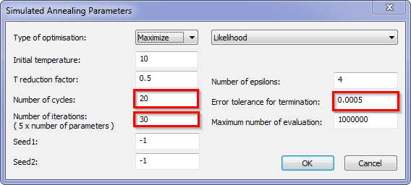

Add a new script on the fit curve and fill as follow
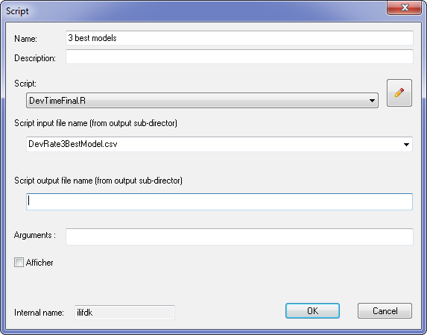

Unchecked the already executed component and click on execute.

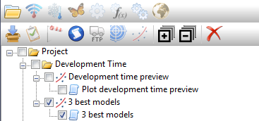
Again it’s a long process and base on an i-7 with 8 CPU, it took ~15 minutes. After BioSIM have been executed. 6 final images (3 model x 2 images by model) will have been created.

Overall maxLL:
EqName | maxLL
Regniere_2012 | -354.0
Wang&Lan&Ding_1982 | -355.7
Hansen_2011 | -358.4

The Régnière model.
The first column is the simulated development rate with the observation.
The second column is the distribution and the cumulative distribution of the relative development time (time of individual/mean time of treatment). The relative development time is the variation between individual in development time. The third (time) and fourth (rate) column are the comparison between the observation and a kind of simulation.

The Wang&Lan&Ding model:
The Hansen model
After examining in detail the 3 best models, we choose the Wang&Lan&Ding because they are more conservative than the 2 other models.

Selecting the final models

Copy the file “/output/DevTime3BestModel.csv” and rename it “/output/DevTimeFinal.csv”. Edit the file and keep only the choose model for each stage. In this case, we only choose the Wang&Lan&Ding model. Save the file.

Model in C++

We only show here how to generate the daily mean rate and the relative development rate. Ask to the BioSIM team to get assistance.

To generate mean rate, enter these equation name and parameters as follow:

static const CDevRateEquation::TDevRateEquation EQ[NB_STAGES] =
{
CDevRateEquation::WangLanDing_1982,//egg
CDevRateEquation::WangLanDing_1982,//L1
CDevRateEquation::WangLanDing_1982,//L2
CDevRateEquation::WangLanDing_1982,//L3
CDevRateEquation::WangLanDing_1982,//L4
CDevRateEquation::WangLanDing_1982,//PrePupa
CDevRateEquation::WangLanDing_1982,//Pupa
};

static const double P[NB_STAGES][6] =
{
{9.217242e-01,1.158581e-01,3.065010e+00,3.200000e+01,3.200000e+01,3.176815e+00},//egg
{1.763115e+00,9.538295e-02,4.266326e+00,3.199998e+01,3.200000e+01,1.576118e+00},//L1
{2.990933e+00,1.265557e-01,4.174986e+00,3.199998e+01,3.200000e+01,1.000002e+00},//L2
{1.975334e+00,1.025401e-01,7.253662e+00,3.200000e+01,3.200000e+01,1.000003e+00},//L3
{1.341273e+00,1.201731e-01,5.660822e+00,3.199994e+01,3.200000e+01,1.000011e+00},//L4
{4.550437e-01,8.897248e-02,6.395555e+00,3.199968e+01,3.200000e+01,1.909403e+00},//PrePupa
{4.731006e-01,1.247642e-01,2.705369e-03,3.200000e+01,3.200000e+01,1.000014e+00},//Pupa
};

The development rate can be directly computed from the class CDevRateEquation

for example:
std::vector<double> p(begin(P[s]), end(P[s]));
double r = max(0.0, CDevRateEquation::GetRate(EQ[s], p, T));

An individual stochastic relative development rate can be compute from the relative development time

const double P[NB_STAGES][1] =
{
//Relative development Time (individual variation): sigma
{0.137226},//Egg
{0.296594},//L1
{0.437863},//L2
{0.382477},//L3
{0.300101},//L4
{0.196098},//PrePupae
{0.135804},//Pupae
};

boost::math::lognormal_distribution<double> lndist(-(P[s][σ]*P[s][σ])/2.0, P[s][σ]);

//generate relative development time
double rT = boost::math::quantile(lndist, m_randomGenerator.RandUniform());
while (rT < 0.2 || rT>2.6)//base on individual observations limits
rT = exp(P[s][μ] * boost::math::quantile(lndist, m_randomGenerator.RandUniform()));

_ASSERTE(!_isnan(rT) && _finite(rT));
//covert relative development time into relative development rate
double rR = 1/rT;

Reference

Régnière, J., Powell, J., Bentz, B., & Nealis, V. (2012). Effects of temperature on development, survival and reproduction of insects: experimental design, data analysis and modeling. Journal of Insect Physiology, 58(5), 634-647.

Sporleder, M., Tonnang, H. E., Carhuapoma, P., Gonzales, J. C., Juarez, H., & Kroschel, J. (2013). 23 Insect Life Cycle Modelling (ILCYM) Software–A New Tool for Regional and Global Insect Pest Risk Assessments under Current and Future Climate Change Scenarios. Potential invasive pests of agricultural crops, 3, 412.

Tonnang, H. E., Sporleder, M., Carhuapoma, P., González, J. C., Juarez, H., & Kroschel, J. (2011). Insect Life-Cycle Modeling (ILCYM) Software: A new tool for regional and global insect pest risk assessments under current and future climate change scenarios.

